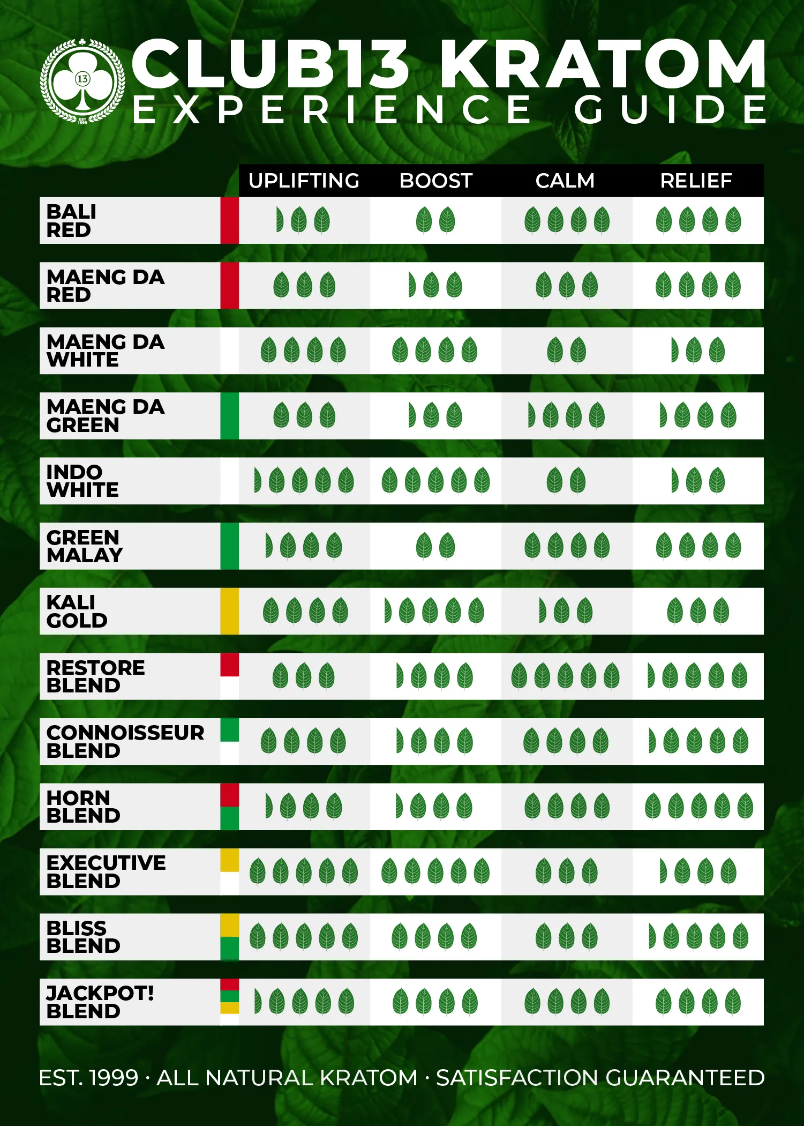  COMPONENT ID TAG  Component# ________ Lot# ____________  Component Name:____________________  ____________________________________  Ctn# _____of ______Date: ______By____  QUARANTINE  CLB010 |  |   COMPONENT ID TAG  Component# ________ Lot# ____________  Component Name:____________________  ____________________________________  Ctn# _____of ______Date: ______By____  QUARANTINE  CLB010
  COMPONENT ID TAG  Component# ________ Lot# ____________  Component Name:____________________  ____________________________________  Ctn# _____of ______Date: ______By____  QUARANTINE  CLB010 |  |   COMPONENT ID TAG  Component# ________ Lot# ____________  Component Name:____________________  ____________________________________  Ctn# _____of ______Date: ______By____  QUARANTINE  CLB010
  COMPONENT ID TAG  Component# ________ Lot# ____________  Component Name:____________________  ____________________________________  Ctn# _____of ______Date: ______By____  QUARANTINE  CLB010 |  |   COMPONENT ID TAG  Component# ________ Lot# ____________  Component Name:_____________________  ____________________________________  Ctn# _____of ______Date: ______By____  QUARANTINE  CLB010

